***PYTHON PROGRAMMING***

***Int-213***

**Topic:** Live cricket score using GUI application in python



***Submitted by:***

|  |  |  |  |
| --- | --- | --- | --- |
| ***NAME*** | ***REG NO:*** | ***ROLL NO*** | ***Section*** |
| N.Pranay | 11902943 | 06 | K19KH |
| T.Praveen | 11908819 | 41 | K19KH |
| B.chaitanya | 11903784 | 26 | K19KH |

***Submitted to:***

Ms.Ankita Wandhawan

***INTRODUCTION :***

The application is about getting an information of live Cricket ongoing IPL using Python .As we all use cricbuzz and other apps to view live ipl scores we can also access the same information through python using some coding .In python we have few libraries which helps in implementing the application .This GUI gives a brief description of the match like team players, scores, bowlers, batsmen etc.

***DATAFLOW DIAGRAMS:***

***LEVEL_0***

USER

ADMIN

***LEVEL_1***

***Match***

***Team***

ADMIN

***Batsmen,bowler***

***Result:***

* The application gives the summary of the live ongoing ipl cricket match or the last match if there is no live on going matches.
* This also give a brief overall result of particular match that was played.
* This also gives a brief scored board wirh batsmen and bowlers , loss of wickets ,extras etc.

***Screenshot***

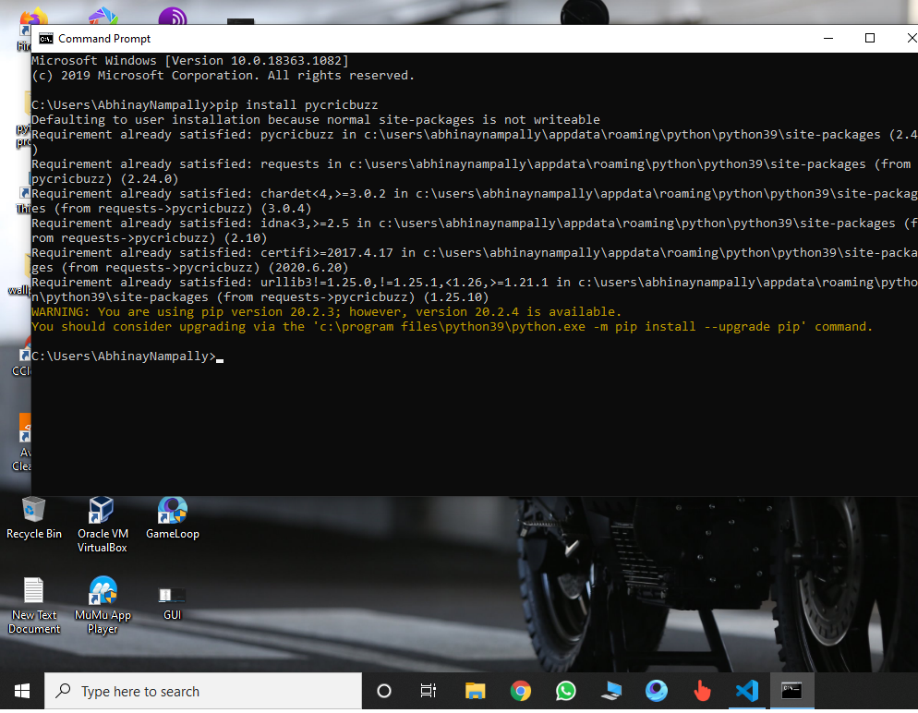

The above picture shows what are the required library to install for on going GUI application in python by command prompt in windows. Firstly install pip function and then pycricbuzz by entering “pip install pycricbuzz” to get the scorecard data from cricbuzz.

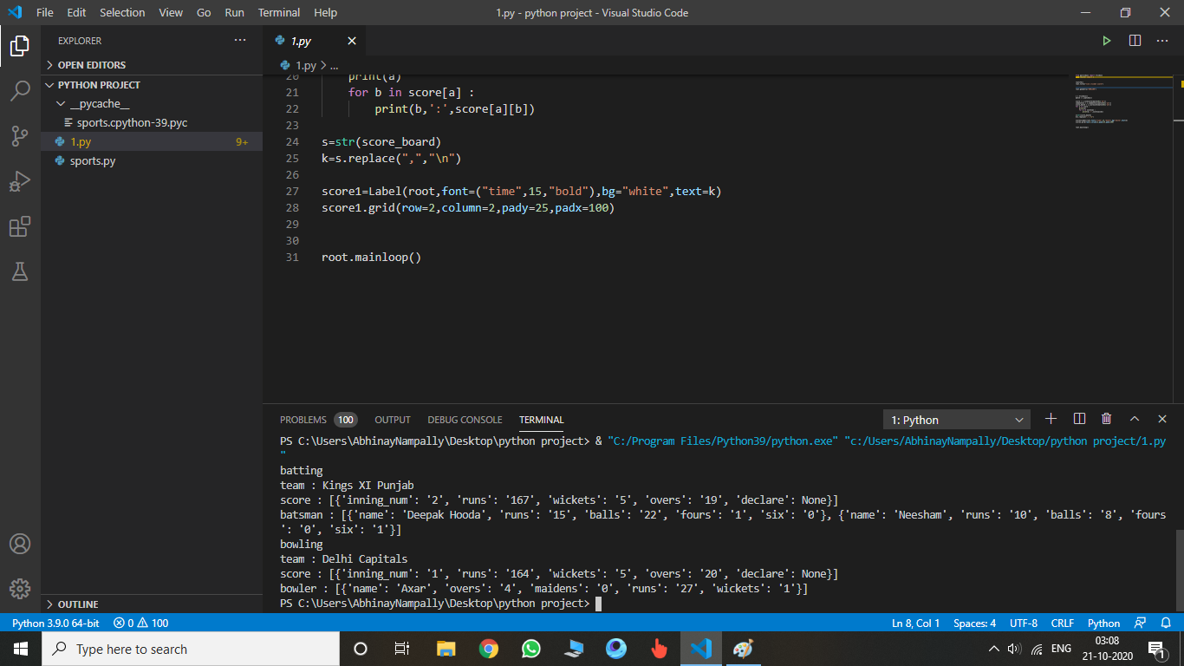

The above image shows the terminal of the given application this helps us when we are unable to get complete data from GUI visualization due to screen resolution.so,we can also get data from terminal.

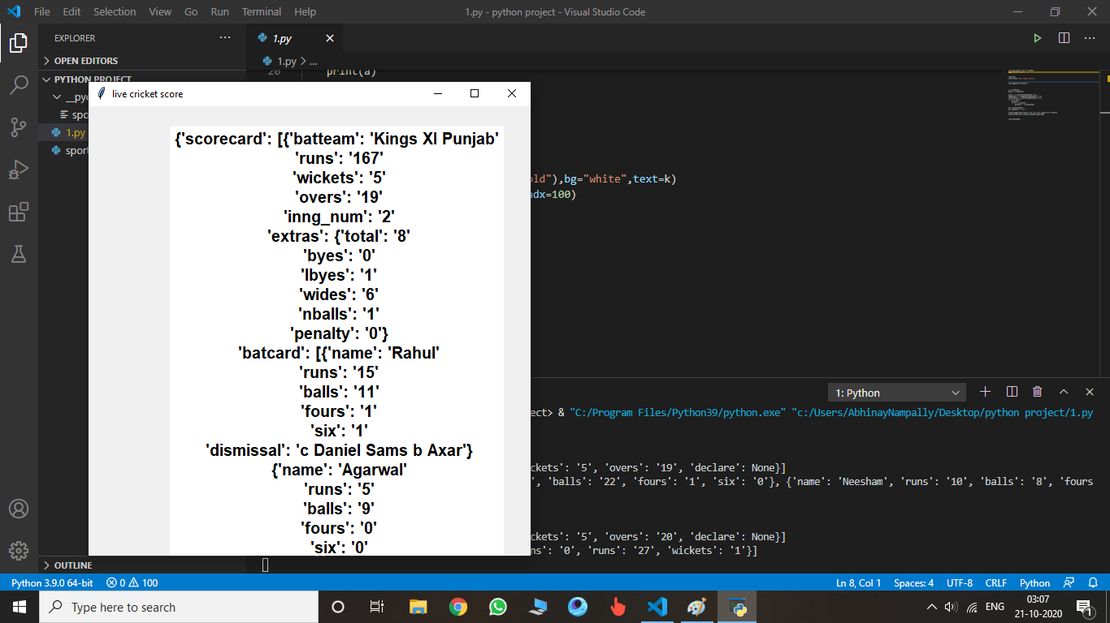

The above picture gives the output of GUI application which gives detailed description of the on going match. As, we can observe the GUI is titled with “live cricket score”. We can name the GUI with whatever name we want and also we can set the resolution of the GUI.

**THANKYOU**